Solution Architecture

This is an hybrid solution, in local environments, the API’s are deployed to manage csv files ingestion and generate data report endpoints, also to trigger the pipeline, in the Azure Cloud is the process transformation responsible for moving data to the SQL database.

Solution Components Diagram

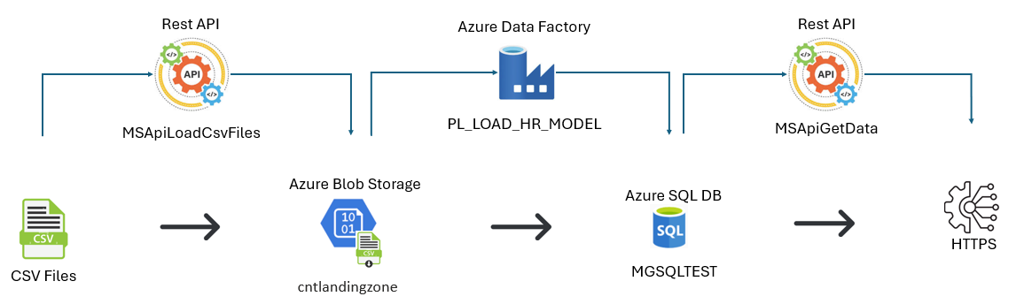

Components

**Rest API**

GIT: <https://github.com/AndresGHUB/MSApiLoadCsvFiles>

Project: MSApiLoadCsvFiles

Objective: Load CSV files from on-premise location to Azure Blob Storage

Controller: LoadCsvToBlobStorage

Action: LoadHistoricalData

URI: <https://localhost:44304/api/LoadCsvToBlobStorage/LoadHistoricalData>

Description: End-point to load data from on-premise directory to cloud Blob Storage

Action: TriggerDFPipeline

URI: <https://localhost:7035/api/LoadCsvToBlobStorage/TriggerDFPipeline>

Description: End-point to trigger the Data Factory Pipeline which extracts data from Blob Storage and load into Azure SQL DB tables.

SQL Files for local database:

GIT: <https://github.com/AndresGHUB/ChallengeSQL/tree/master/Local>

**Azure Blob Storage**

GIT: <https://github.com/AndresGHUB/ChallengeAzureTemplates>

Resource: **mglandingzonetest**

Container: cntlandingzone

**Azure Data Factory**

GIT: <https://github.com/AndresGHUB/ChallengeAzureTemplates>

Resource Group: rsmgtest

Resource: [df-mg-test001](https://portal.azure.com/#@godata.com.ec/resource/subscriptions/815fee8d-3fcd-413a-8555-ecaf0be94a4f/resourceGroups/rsmgtest/providers/Microsoft.DataFactory/factories/df-mg-test001)

Pipeline: PL_LOAD_HR_MODEL

**Azure SQL Database**

GIT: <https://github.com/AndresGHUB/ChallengeSQL>

Resource Group: rsmgtest

Resource: mgsqltest (serv-mg/mgsqltest

Server: serv-mg

Database: MGSQLTEST

SQL Files for cloud database:

GIT: <https://github.com/AndresGHUB/ChallengeSQL/tree/master/Cloud>

**Rest API**

GIT: <https://github.com/AndresGHUB/MSApiGetData>

Project: MSApiGetData

Objective: Generate data to deploy into end-points (Reports)

Controller: ReportHiringModel

Action: GetHiredByDepartments

URI: <http://localhost:5047/api/ReportHiringModel/GetHiredByDepartments>

Description: End-point to generate hired by Departments, Jobs shown by quarters

Action: GetCountAvegareDepartments

URI: <http://localhost:5047/api/ReportHiringModel/GetCountAvegareDepartments>

Description: End-point to generate hired by Departments over average

**Testing**

GIT: <https://github.com/AndresGHUB/ChallengeTesting>

Project: TestApiProject